Installing Ansys 18.0 in Microsoft Window 10

Note: It is recommended to install “Microsoft Visual Studio Express 2015” Before installing Ansys 18.0. To download “Microsoft Visual Studio Express 2015” from cc ftp site.

The Ansys 18.0 is compressed to a single zipped file and available on cc ftp site. Extract the zipped file of Ansys 18.0 to local driver and run the setup after extracted folder.

1. Click on “Install ANSYS Products” button.

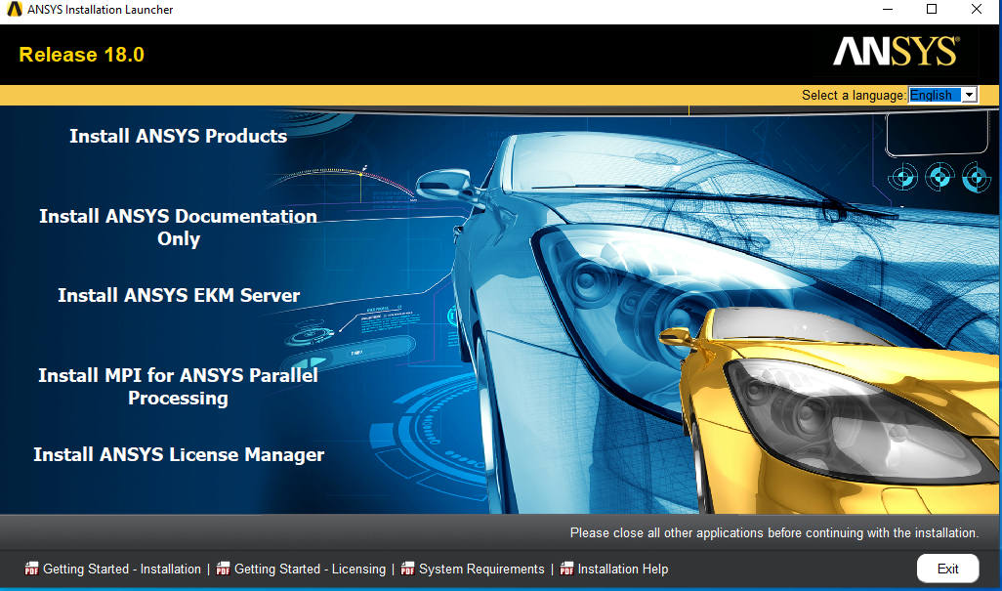

1. Select “I Agree” and Click on the “>” button.

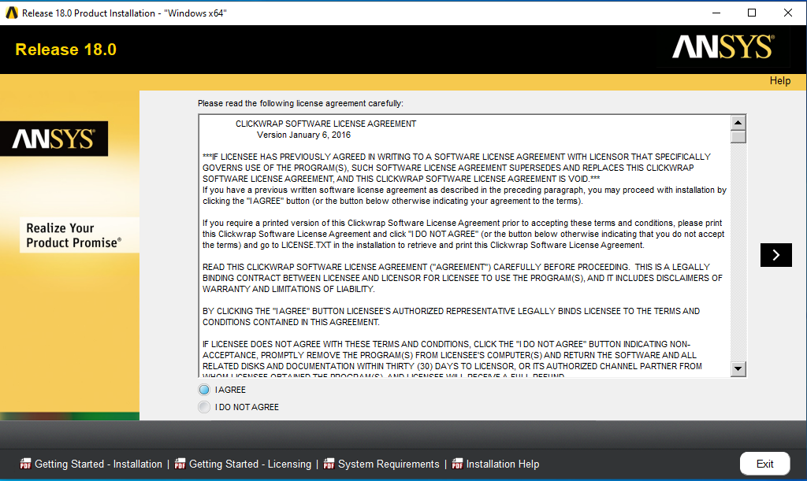

1. Enter the installation directory “install directory : C:\Program Files\ANSYS inc” and Check the Option for “ Associate the extensions with ANSYS products: Selecting this feature allows you to open the files with the appropriate program by double-clicking the file in window explore”. And click on “>” button.

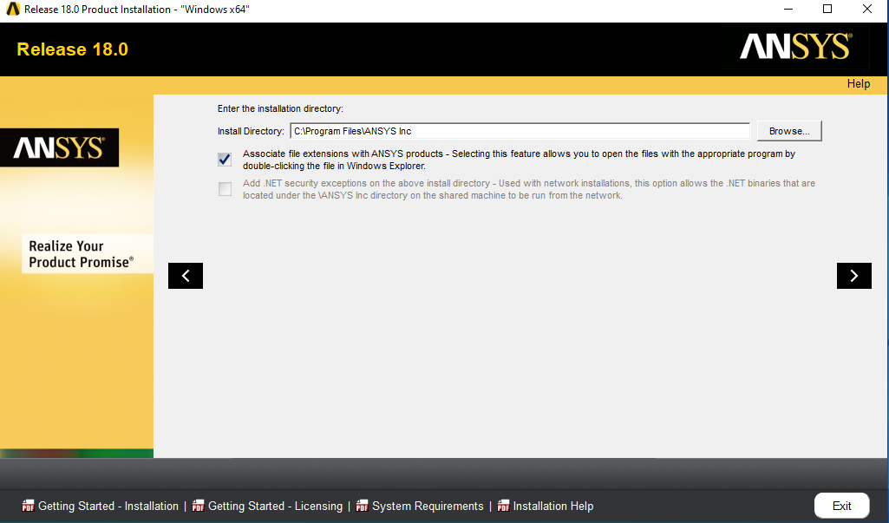

1. Select all products and Click on the “>” button.

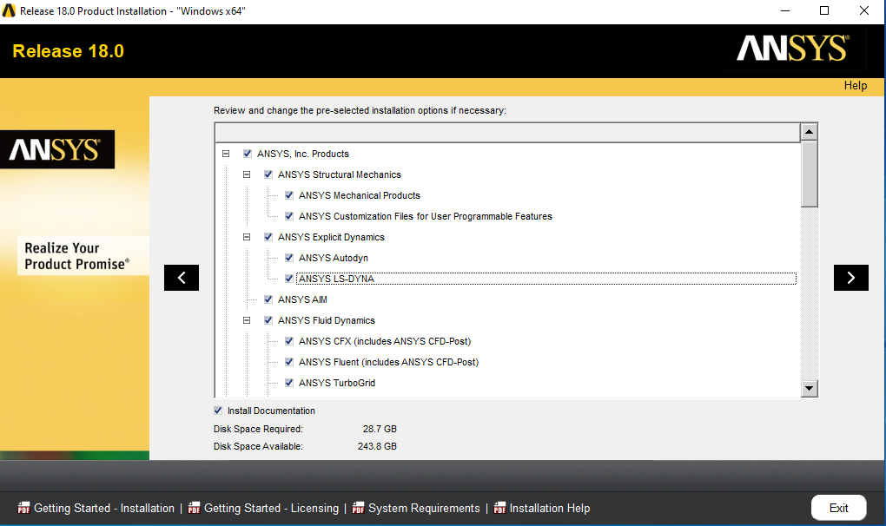

1. Again select all products as per requirement and click on the “>” button.

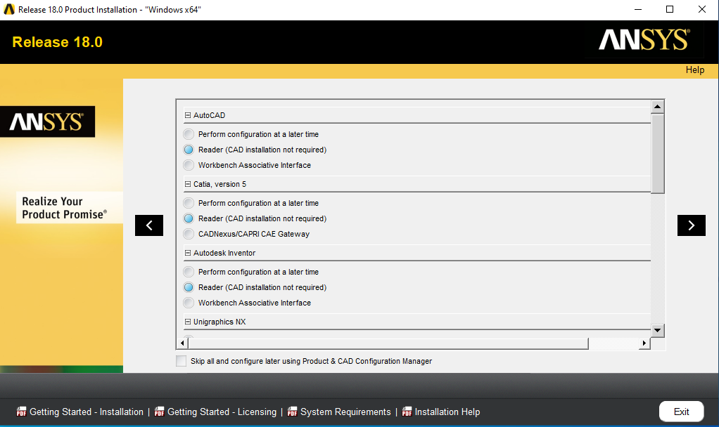

1. It show “Selected Platforms Products” and click on “>” button.

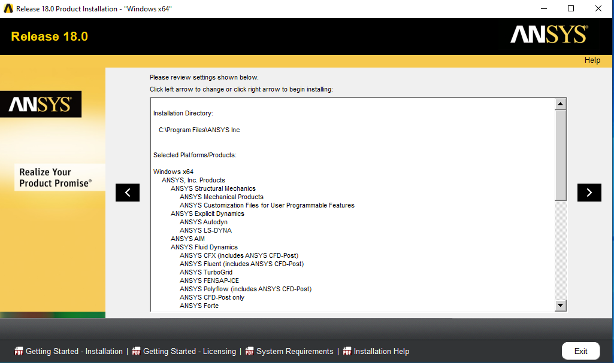

1. Wait a serveral minute for Ansys 18.0 installation to complete then click on “>” button.

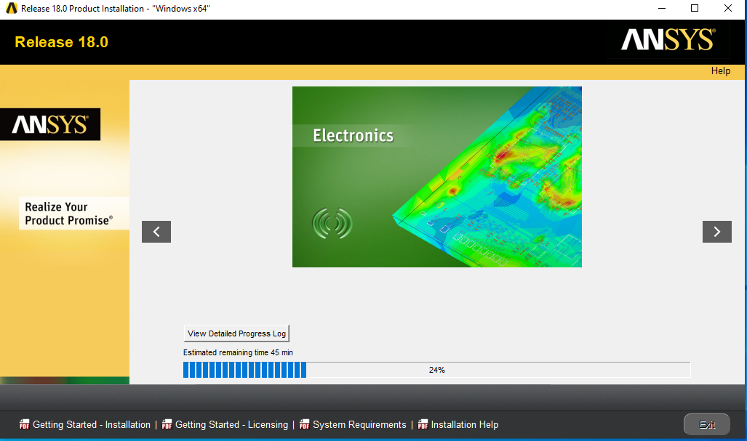

1. Select Uncheck box “Launch survey upon exiting” and click on “Exit” button.

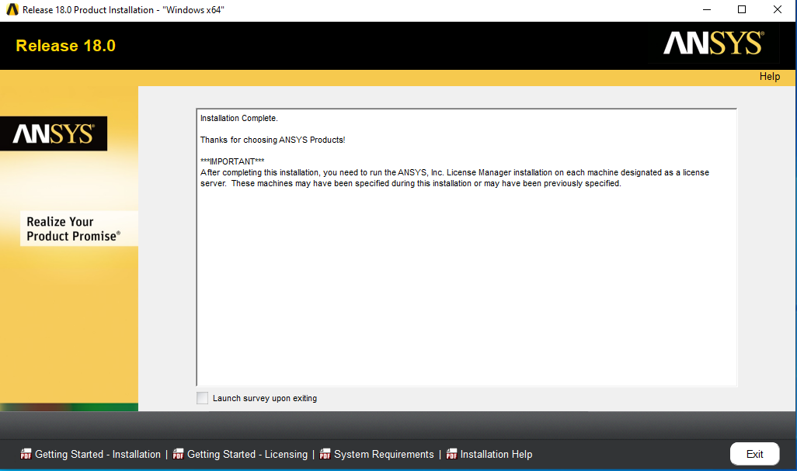

1. Open “ClientANSLIC_ADMIN Utility” from the START menu and click on “Specify the Lincence Server Machine”.

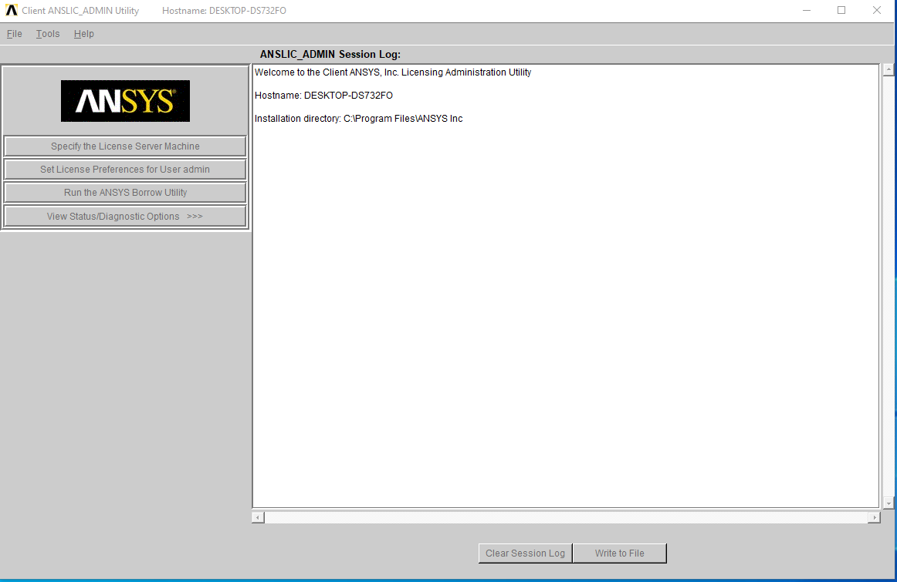

1. Input the Ansys Licence Server IP Add in “Hostname”. ( Network Licence is “akash3.cc.iitk.ac.in or 172.31.1.198).

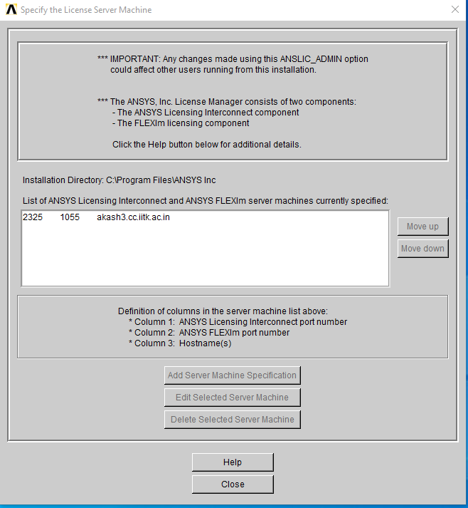

1. Preview of the Software as below.

